Explanatory note on the SEE TSOs proposal for methodology for redispatching and countertrading cost-sharing in accordance with Article 74 of the Commission Regulation (EU) 2015/1222 of 24 July 2015 establishing a Guideline on Capacity Allocation and Congestion Management

September 2018

Table of Contents
1. INTRODUCTION 3
2. FULL LINE DECOMPOSITION METHODOLOGY (“FLD”) 3
2.1 Definitions 3
2.2 FLD method 4
2.3 Main characteristics of FLD 10
3. COST SHARING BASED ON THE FLD METHOD 10
3.1 Proportional netting by category 11
3.2 Proportional netting 12

INTRODUCTION
This document (the Document) is a note accompanying the common proposal and the related explanatory note developed by the Transmission System Operators of the SEE Capacity Calculation Region (hereafter referred to as “TSOs”) for common methodology for redispatching and countertrading cost sharing (hereafter referred to as the “Cost Sharing Proposal”) in accordance with Article 74 of Commission Regulation (EU) 2015/1222 establishing a guideline on Capacity Allocation and Congestion Management (hereafter referred to as the “CACM Regulation”).
In particular, the Document describes the different possible approaches examined for the redispatching and countertrading cost-sharing methodology by the TSOs. The aim of the Document is to provide SEE NRAs with all relevant elements to support the decision on the Cost Sharing Proposal.
TSOs explored a number of scenarios based on the key relevant decisional topics:
- Cost sharing principles: Causer, Socialization, Prioritization
- Methodologies: Full Line Decomposition (FLD)
In the following chapter a detailed overview on the FLD methodology is given.
In section 3, the flow decomposition method which is used to define the burdening and relieving flows is related to the related costs per bidding zone.

FULL LINE DECOMPOSITION METHODOLOGY (“FLD”)

In order to determine the decomposition of the flow per network element, a methodology has been developed. Full line decomposition (FLD) method is a methodology that allows a complete partitioning of the power flow for each network element of the power system, based on a network model. The FLD method produces unique results for each network model and is independent of slack bus location and Generator Shift Keys (GSKs).

Definitions

The used “flow” terminology is based on the ENTSO-E definitions, agreed in September 2014. The physical flow is the sum of different types of flows that are present at the same time. In a meshed AC interconnected power system, four types of flows are distinguished, depending on the location of the power source (generator), the power sink (load) and the line:
• Internal flow is defined as the flow on a line where the source and sink and the whole line are located in the same zone
• Loop flow is defined as the flow on a line where the source and sink are located in the same zone and the line or part of the line is located in a different zone.
• Import/Export flow is defined as the flow on a line where the source and sink are in different zones and the line or part of the line is in either one of these zones
• Transit flow is defined as the physical flow on a line where the source, sink and all parts of the line are all located in different zones.

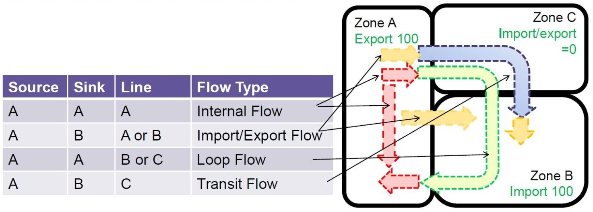

Fig. 1: ENTSO-E flow definitions

In addition to the above flow definitions, the following flows attributes are defined:
• Burdening flow is a component of the physical flow on a specific line which flows in the same direction as the whole physical flow.
• Relieving flow is a component of the physical flow on a specific line which flows in the opposite direction as the whole physical flow.

FLD method

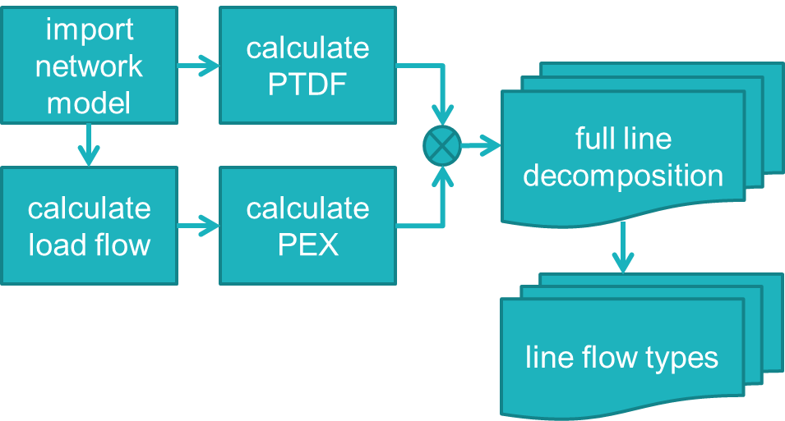

Figure 2: FLD process

FLD is a mathematical method that is based on a DC load flow and on the calculation of nodal Power Transfer Distribution Factors (PTDFs). These PTDFs describe the linear relation between the net power injections into the grid and the active power flows through the lines.

The FLD process, starts with the import of a network model. The PTDFs are calculated directly from the network characteristics. A load flow is calculated and the Power Exchange matrix (PEX) is derived from the physical line flows. The full line decomposition is obtained by multiplying the PTDF and PEX values. The flow types for individual lines are calculated by filtering and adding the various flow components according to each type of flow.

The Calculate PTDF and PEX
The PTDF and PEX values are calculated by matrix manipulation methods, directly after importing the network model. The calculation of the PEX requires a load flow analysis (at this moment DC load flow), which can be done by a separate flow calculation or by using the PTDF values.

Calculate PTDF
The nodal Power Transfer Distribution Factor (PTDF) matrix describes the linear relation between the net power injections at each node and the resulting active power flows through all lines. The calculation of the nodal PTDF only requires information about the network topology and the line characteristics.

Node-to-node PTDFs
By subtracting the PTDFs from two specific nodes, the corresponding node-to-node PTDFs are calculated. The node-to-node PTDF for line l, ${\text{PTDF}}_{\text{l,n2n}}$, shows how a change in the bilateral exchange between these nodes (${\text{ΔBE}}_{\text{n2n}}$) influences the power flow (${\text{ΔP}}_{\text{l}}$) on the line l:

${\text{ΔP}}_{\text{l}}\text{ = }{\text{PTDF}}_{\text{l,n2n}}\text{ ∙ }{\text{ΔBE}}_{\text{n2n}}$ (1)

A balanced exchange between two nodes does not lead to a change at the slack node. The dependency on the slack node, and consequently its location, is therefore cancelled out in the node-to-node PTDF.
Equation Error! Reference source not found. shows that it is possible to compute the power flows in the network once the bilateral exchanges between each pair of nodes are known. These bilateral exchanges can be grouped to form the NxN Power Exchange (PEX) matrix. As each bilateral power exchange is a cause for a specific type of power flow, the PEX matrix is a basis for a flow partitioning method. Hence, the aim is to build the PEX matrix from a given network model to compute the various flow types in each branch of the system.

PEX

The PEX matrix contains the power that is exchanged between each generator node and each load node. PEXij is the power produced in node i for the load in node j. The calculation of the PEX matrix only requires the active power flow and the topology in the network model, based on Kirchhoff’s current law and the proportional sharing principle.
For a network consisting of N buses and L lines,
  - ${\text{P}}_{\text{G}}$ is the vector of N nodal generations
  - ${\text{P}}_{\text{D}}$ is the vector of N nodal demands
  - $\text{F}$ is the vector of L branch flows
The incidence (or connectivity) matrix C is a LxN matrix describing the topology of a network, i.e. which lines are connected to which nodes. The incidence matrix C is split into the matrix ${\text{C}}_{\text{d}}$ that contains the 1's of C and a matrix ${\text{C}}_{\text{u}}$ that contains the -1's, such that $\text{C = }{\text{C}}_{\text{d}}\text{ + }{\text{C}}_{\text{u}}$.
The matrix ${\text{F}}_{\text{d}}$ is defined such that ${\text{F}}_{{\text{d}}_{\text{ij}}}$ is equal to the flow on branch i-j towards node j:

${\text{F}}_{\text{d}}\text{ = - }{\text{C}}_{\text{d}}^{\text{T}}\text{ diag(F) }{\text{C}}_{\text{u}}$ (2)

Where the operator diag() denotes a diagonal matrix constructed from a vector.

The nodal power P of a bus is defined as the sum of nodal inflows and local generation, which is equal to the sum of nodal outflows and local demand:

$\text{P = }{\text{P}}_{\text{D}}\text{ + }{\text{F}}_{\text{d}}\text{e}$ or $\text{P = }{\text{P}}_{\text{G}}\text{ + }{\text{F}}_{\text{d}}^{\text{T}}$e (3)

Where e is the Nx1 identity vector of ones.

The ${\text{A}}_{\text{d}}$ and ${\text{A}}_{\text{u}}$ matrices are referred to as the downstream and upstream distribution matrices. They allow to relate the vectors of power demands and power generations to the vector of nodal powers. They can be derived directly from the line flows and the nodal power, as:

${\text{A}}_{{\text{d}}_{\text{ij}}}\text{ = }\left\{\begin{aligned}\text{1 for i = j} \\ \text{- }\frac{\left|{\text{P}}_{\text{ji}}\right|}{{\text{P}}_{\text{j}}}\text{ for j }\text{∈} {\text{α}}_{\text{i}}^{\text{d}}\end{aligned}\right.$ (4)
${\text{A}}_{{\text{u}}_{\text{ij}}}\text{ = }\left\{\begin{aligned}\text{1 for i = j} \\ \text{- }\frac{\left|{\text{P}}_{\text{ji}}\right|}{{\text{P}}_{\text{j}}}\text{ for j }\text{∈} {\text{α}}_{\text{i}}^{\text{u}}\end{aligned}\right.$ (5)

Where ${\text{P}}_{\text{ji}}$ is the flow on the line from node i to node j, ${\text{P}}_{\text{j}}$ is the nodal power at node j, ${\text{α}}_{\text{i}}^{\text{d}}$ is the set of downstream nodes directly supplied from node i and ${\text{α}}_{\text{i}}^{\text{u}}$ is the set of upstream nodes directly supplying node i.
It can be shown that ${\text{A}}_{\text{d}}$ and ${\text{A}}_{\text{u}}$ are invertible . The contribution to the power flows in the network, due to individual generators and loads can now be calculated by either

$\text{P = }{\text{A}}_{\text{d}}^{\text{-1}} {\text{P}}_{\text{D}}$ (6)

or, equivalently,

$\text{P = }{\text{A}}_{\text{u}}^{\text{-1}} {\text{P}}_{\text{G}}$ (7)

An element (i,j) of ${\text{A}}_{\text{d}}^{\text{-1}}$ shows the share of the nodal power at node j that is supplied from node i, whereas an element (i,j) of ${\text{A}}_{\text{u}}^{\text{-1}}$ shows the share of the nodal power at node j that supplies node i. The element (i,j) of the PEX matrix can now be expressed as follows:

${\text{PEX}}_{\text{ij}}\text{ = }{\text{P}}_{{\text{D}}_{\text{j}} } \frac{{\text{P}}_{{\text{G}}_{\text{i}} } {\text{A}}_{{\text{d}}_{\text{ij}}}^{\text{-1}}}{{\text{P}}_{\text{i}}}$ (8)

In which $\frac{{\text{P}}_{{\text{G}}_{\text{i}}}}{{\text{P}}_{\text{i}}}$ is the proportion of the nodal power ${\text{P}}_{\text{i}}$ coming from the local generation ${\text{P}}_{{\text{G}}_{\text{i}}}$.
The same result is obtained by using the inverse of the upstream distribution matrix:

${\text{PEX}}_{\text{ij}}\text{ = }{\text{P}}_{{\text{G}}_{\text{i}} } \frac{{\text{P}}_{{\text{D}}_{\text{j}}} {\text{A}}_{{\text{u}}_{\text{ji}}}^{\text{-1}}}{{\text{P}}_{\text{j}}}$ (9)

The PEX matrix contains the power that is exchanged between each generator node and each load node. PEXij is the power produced in node i for the load in node j. The calculation of the PEX matrix only requires the active power flow in the network model.

Full Line Decomposition

The flow on line l due to the exchange of power from node i to node j can now be calculated as in (10):

${\text{F}}_{l\text{,ij}}\text{ =}{\text{ PTDF}}_{l\text{,ij}}\text{ ∙ }{\text{nodal PEX}}_{\text{ij}}$ (10)

Where nodal PEXij is the power exchange between the nodes. The node-to-node PTDFij is the relation between these power exchanges and the line flow. The power flow on this particular line is thus decomposed into the contributions of the individual node-to-node power exchanges between all nodes in the network. These flow components can be grouped and summed together to calculate the ENTSO-E flow types.
There are two possible scenarios: either line l is an internal line or it is a tie-line. Each of these cases is considered below.
First, it is assumed that line l is an internal line, belonging to zone A. The internal flow on this line is defined as the flow caused by the power exchanges between generators and loads belonging to the same zone A. By summing the flow contributions for each possible combination of nodes in the group of nodes of zone A, the internal flow is calculated. This internal flow for line l is calculated as follows:

$${\text{Internal flow}}_{l}\text{ = }\sum_{Z_{i}=Z_{j}=A}{{\text{PTDF}}_{l\text{,ij}}\text{ ∙ }{\text{nodal PEX}}_{\text{ij}}}$$ | (11)

Where Z_{i} is the zone of node i. The loop flow on line l is defined as the flow due to the internal power exchanges between generators and loads in each of the other zones. The loop flow is the sum of the contributions for all combinations of two nodes in the same zone but other than zone A. The loop flow for line l is calculated as:

$${\text{Loop flow}}_{l}\text{ = }\sum_{\begin{aligned}Z_{i}≠A, { Z}_{j}≠A \\ Z_{i}=Z_{j}\end{aligned}}{{\text{PTDF}}_{l\text{,ij}} {\text{∙ nodal PEX}}_{\text{ij}}}$$ | (12)

The import flow on line l can be derived by summing the contributions of the power supplied by the generators of all the other zones to the loads belonging to zone A:

$${\text{Import flow}}_{l}\text{ = }\sum_{\begin{aligned}Z_{i}≠A, { Z}_{j}=A \end{aligned}}{{\text{PTDF}}_{l\text{,ij }}{\text{∙ nodal PEX}}_{\text{ij}}}$$ | (13)

The export flow on line l can be derived by summing the contributions of the power supplied by the generators of zone A to all the loads belonging to the other zones:

$${\text{Export flow}}_{l}\text{ = }\sum_{\begin{aligned}Z_{i}=A, { Z}_{j}≠A \end{aligned}}{{\text{PTDF}}_{l\text{,ij }}{\text{∙ nodal PEX}}_{\text{ij}}}$$ | (14)

The transit flow on line l can be obtained by summing the contributions of the power supplied by the generators in zones B≠A to loads in zones A≠B:

$${\text{Transit flow}}_{l }\text{= }\sum_{\begin{aligned}Z_{i}≠A, { Z}_{j}≠A \\ Z_{i}≠Z_{j}\end{aligned}}{{\text{PTDF}}_{l\text{,ij}} {\text{∙ nodal PEX}}_{\text{ij}}}$$ | (15)

Secondly, assume that line l is a tie-line connecting zone A and zone B. In this circumstance, since the line is not internal to any zone, the internal flow is zero and the loop flow amounts to the internal power exchanges between generators and loads in each of the zones:

$${\text{Loop flow}}_{\text{l}}\text{ = }\sum_{\begin{aligned}Z_{i}=Z_{j}\end{aligned}}{{\text{PTDF}}_{l\text{,ij}} {\text{∙ nodal PEX}}_{\text{ij}}}$$ | (16)

The import/export flow is now due to the power supplied by the generators of zone A to the loads of zone B and the power supplied by the generators of zone B to the loads of zone A:

$${\text{Import/export}}_{\text{l}}\text{ = }\sum_{\begin{aligned}Z_{i}=A|B or { Z}_{j}=A|B \\ Z_{i}≠Z_{j}\end{aligned}}{{\text{PTDF}}_{l\text{,ij}} {\text{∙ nodal PEX}}_{\text{ij}}}$$ | (17)

Where Z_{i}=A|B means: node i is in zone A or zone B.
Finally, the transit flow for a tie-line can be expressed as:

$${\text{Transit flow}}_{\text{l }}\text{= }\sum_{\begin{aligned}Z_{i}≠A|B and { Z}_{j}≠A|B \\ Z_{i}≠Z_{j}\end{aligned}}{{\text{PTDF}}_{l\text{,ij}} {\text{∙ nodal PEX}}_{\text{ij}}}$$ | (18)

Where Z_{i}≠A|B means: node i is not in zone A and not in zone B

Main characteristics of FLD

The FLD method has the following characteristics:
  - It agrees with the commonly accepted proportional sharing principle,
  - It can be applied to any network model,
  - It is independent of slack bus location,
  - It is independent of GSK,
  - It is robust and fast
  - Its results are compliant with the physical properties of the network,
  - The sum of all flow types for each network element exactly equals the total physical flow,
  - It identifies relieving and burdening flows.

COST SHARING BASED ON THE FLD METHOD

Flow decomposition methods will identify both relieving and burdening flows. Before flows are being prioritised, there are several options to net burdening flows with relieving flows. According to the causation principle based on the prioritisation of flows, flows are netted per category. There is however an issue using this principle in case there is no burdening flow type available to net against a relieving flow. In case netting per category would be used, it would mean that an additional method should always be available to handle the relieving flows which cannot be netted immediately. In total 2 different options have been identified and these are displayed in Error! Reference source not found.Table 1.

Table 1
Nr. Crt. | Name | Type | Description
1 | Proportional netting per category | Netting proportional per category | Net the flows per category proportionally. Relieving flows are distributed proportional with burdening flows within each category, without distinction between bidding zones.
2 | Proportional netting | Netting proportional | Proportional netting without taking into account the categories

Proportional netting per category

With proportional netting per category the different flow categories with burdening and relieving flows are proportionally netted. In this option there is no distinction made if a bidding zone is creating burdening and/or relieving flows. In the netting principle the prioritisations of the flow types are taken into account. Following steps are taken:
- Net overload percentage is determined
- Share per flow category is calculated, starting with flow with highest priority. This will be done for every category causing the overload and will not exceed the total overload percentage. This will happen according to following equation:

$${\%share}_{flow x}= \frac{{\%overload}_{flow x}}{\%overload}$$

In case the share of the flow category exceeds the (remaining) overload, the %overload_{flow x} is set equal to the (remaining) overload;
- Per overload category the share per bidding zone (BZ) is calculated according to following equation:

$$\%BZ=(\frac{{{BZ}_{burdening}}_{ flow x}}{{{Tot}_{Burdening}}_{flow x}})×{\%share}_{flow x}$$

- The total share of costs is calculated per bidding zone by summing up the calculated bidding zone shares from previous step 3.

In Figure 1 is an example of the proportional netting per category principle presented.
Loop Flows and Imp/Exp Flows Penalized

Share for Loop Flows: 20%/25%= 80%
BZ A : (20%/35%)*80%=46%
BZ B : (15%/35%)*80%=34%

Share for Import/Export: 5%/25%= 20%
BZ A : (30%/80%)*20%=7.5%
BZ C : (50%/80%)*20%=12.5%

Total :
BZ A : 53.5%
BZ B : 34%
BZ C : 12.5%
Figure 1 Proportional netting per category

Following can be concluded out of this principle:
Pros:
- This option does not mix categories.
Cons:
- The solution does not provide a solution in case the share of a relieving flow category is bigger than the burdening part or there is no burdening part; Shall be complemented by another principle such as proportional without category;

Proportional netting without category

With proportional netting the sum of the relieving flows is proportional netted with the different categories of burdening flows. According to this principle all burdening flows types get relieved by the relieving flows, without taking into consideration the categories and creators of the relieving flows. Following steps are taken:
- Net overload percentage is determined
- The flow after netting per burdening category is calculated via following equation:
$$Flow after netting =Gross Flow - \frac{Gross Flow}{Total Burdening Flows}×Total Relieving Flows$$
The same formula can be used to calculate the flow share for an individual bidding zone after netting
- Share per flow category is calculated, starting with flow with highest priority. This will be done for every category causing the overload and will not exceed the total overload percentage. This will happen according to following equation:

$${\%share}_{flow x}= \frac{{\%overload}_{flow x}}{\%overload}$$

In case the share of the flow category exceeds the (remaining) overload, the %overload_{flow x} is set equal to the (remaining) overload;

- Per overload category the share per bidding zone is calculated according to following equation:
$$\%BZ=(\frac{{{BZ}_{burdening}}_{ flow x}}{{{Tot}_{Burdening}}_{flow x}})×{\%share}_{flow x}$$

The total share of costs is calculated per bidding zone (when applicable) by summing up the calculated bidding zone shares from previous step 4.
Loop Flows and Imp/Exp Flows Penalized

Loop flow after netting:
BZ A : 20% - (20%/150%) * 25% = 16,6%
BZ B : 15% - (15%/150%) * 25% = 12,5%
Total loop flow share after netting
35% - (35%/150%) * 25% = 29,17%
Loop Flows Penalized
Share for Loop Flows: As the total loop flow share (29,1%) is > overload (25%), the loop flow share is 100% (25%/25%=100%)
BZ A : (16,6%/29,1%) * 100% =57%
BZ B : (12,5%/29,1%) * 100% =43%
Total:
BZ A : 57%
BZ B : 43%

Figure 2 Proportional netting principle

Following can be concluded out of this principle:
Pros:
- No issues with netting in compare netting per category or bidding zone in case no burdening flow type is available against a relieving flow;
- Non-discriminatory;

SEE CCR TSOs will use the method in 3.2 in order to distribute the costs that will arise from the activation of the RDCT procedure. In case some cost is due to TSOs outside the SEE CCR (other than GR-BG-RO), then based on the socialization principle, that cost will be shared equally among the SEE CCR TSOs.

